**Assignment- 1**

**1.Design the above database with following table by applying Primary key and Foreign key**

Create database CustomerDetails;

USE CustomerDetails;

**Create Customer Table**

Create table Customer(

ID int primary key,

Firstname nvarchar(40) NOT NULL,

LastName nvarchar(40),

City nvarchar(40),

Country nvarchar(40),

Phone nvarchar(20));

**Create OrdersTable**

create table Orders(

ID int PRIMARY KEY,

OrderDate datetime NOT NULL,

OrderNumber nvarchar(10),

CustomerId int FOREIGN KEY REFERENCES Customer(ID),

TotalAmount decimal(12,2));

**Create OrderItem Table**

create table OrderItem1(

ID int PRIMARY KEY NOT NULL,

OrderId int FOREIGN KEY REFERENCES Orders(ID) ,

ProductId int FOREIGN KEY REFERENCES Product(ID),

UnitPrice decimal(12,2),

Quantity int);

**Create Product Table**

create table Product(

ID int PRIMARY KEY,

ProductName nvarchar(50),

UnitPrice decimal(12,2),

isDiscontinued bit);

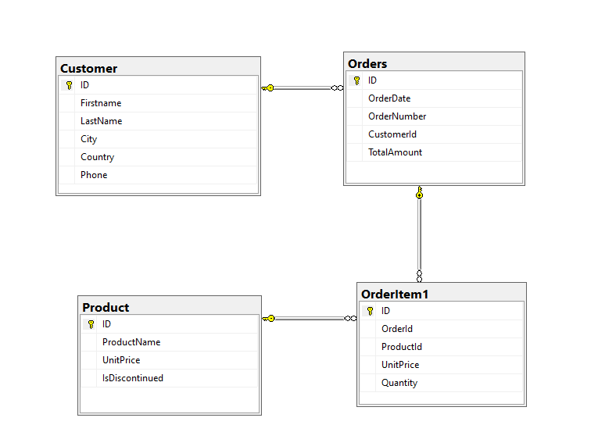

**2.Insert Records in all tables**

**Customer Table:**

->insert into Customer(ID,FirstName,LastName,City,Country,Phone)values (1,'Priya','Jadhav','Mumbai','India',9876543234);

insert into Customer(ID,FirstName,LastName,City,Country,Phone)values (2,'Divya','Kamble','Pune','India',8876543234);

insert into Customer(ID,FirstName,LastName,City,Country,Phone)values (3,'Shravya','Mane','Satara','India',9765487604);

insert into Customer(ID,FirstName,LastName,City,Country,Phone)values (4,'Shraddha','Bhor','Nashik','India',9576587459);

insert into Customer(ID,FirstName,LastName,City,Country,Phone)values (5,'Rani','Deshmukh','Pune','India',8834293234);

**Orders Table:**

insert into Orders(ID,OrderDate,OrderNumber,CustomerId,TotalAmount)values(1,CAST('5-APR-2022' AS datetime),111,1,500);

insert into Orders(ID,OrderDate,OrderNumber,CustomerId,TotalAmount)values(2,CAST('6-APR-2022' AS datetime),112,2,1000);

insert into Orders(ID,OrderDate,OrderNumber,CustomerId,TotalAmount)values(3,CAST('7-APR-2022' AS datetime),113,3,4000);

insert into Orders(ID,OrderDate,OrderNumber,CustomerId,TotalAmount)values(4,CAST('8-APR-2022' AS datetime),114,4,2000);

insert into Orders(ID,OrderDate,OrderNumber,CustomerId,TotalAmount)values(5,CAST('9-APR-2022' AS datetime),115,5,3800);

**OrderItem Table:**

insert into OrderItem1(ID,OrderId,ProductId,UnitPrice,Quantity)values(1,1,1,200,6);

insert into OrderItem1(ID,OrderId,ProductId,UnitPrice,Quantity)values(2,2,2,300,5);

insert into OrderItem1(ID,OrderId,ProductId,UnitPrice,Quantity)values(3,3,3,600,3);

insert into OrderItem1(ID,OrderId,ProductId,UnitPrice,Quantity)values(4,4,4,900,7);

insert into OrderItem1(ID,OrderId,ProductId,UnitPrice,Quantity)values(5,5,5,700,9);

**Product Table:**

INSERT INTO Product(ID,ProductName,UnitPrice,IsDiscontinued)values(1,'Microphone',300,10202);

INSERT INTO Product(ID,ProductName,UnitPrice,IsDiscontinued)values(2,'Mouse',200,12112);

INSERT INTO Product(ID,ProductName,UnitPrice,IsDiscontinued)values(3,'TV',300,10922);

INSERT INTO Product(ID,ProductName,UnitPrice,IsDiscontinued)values(4,'Keyboard',300,22312);

INSERT INTO Product(ID,ProductName,UnitPrice,IsDiscontinued)values(5,'Camera',300,11112);

**3.In Customer table FirstName Attribute should not accept null value**

drop index IndexCustomerName on Customer;

ALTER TABLE Customer alter COLUMN FirstName nvarchar(40) NOT NULL;

**4.In Order table OrderDate should not accept null value**

drop index IndexOrdersOrderDate on [Orders];

ALTER TABLE [Orders] alter COLUMN OrderDate datetime NOT NULL;

**5. write a query to display Country whose name starts with A or I**

->select * from Customer where Country LIKE 'A%' OR Country LIKE 'I%';

**6 .Display all customer details**

->select * from Customer;

**7. write a query to display whose name of customerwhose third character is i**

->select * from Customer where FirstName LIKE '__i%';